National STEM Competition 2020

Registration Form

Team name: BUET_Rendezvous

- Name of the Institution: Bangladesh University of Engineering and Technology (BUET)

- Team members:

Name Department Student ID Academic Year Email

1 Rahad Arman Nabid EEE 201506142 4th ran.nabid@gmail.com

2 Md. Jahin Alam EEE 201606040 3rd jahin00003@gmail.com

3 Shams Nafisa Ali BME 201618019 3rd snafisaali100@gmail.com

4 Manzil-e Akbar Khan BME 201618029 3rd manzilkhan911@gmail.com

5 Fardeen Ahmed BME 201618030 3rd awrka.goku@gmail.com

- Team Leader: Rahad Arman Nabid

- Supervised by: Md. Farhad Hossain
Professor
PhD (Wireless Networking), MSc Engg. (EEE, BUET), BSc Engg. (EEE, BUET)

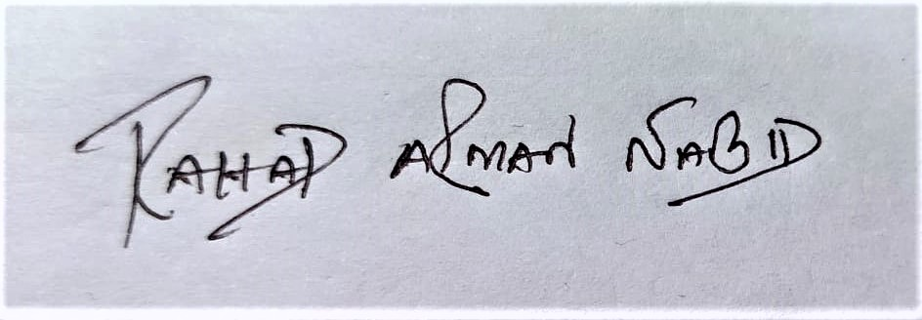
_________________________

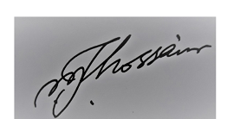

_______________________

Signature of the team leader

Signature of the Supervisor

(with official seal)

National STEM Competition 2020

Concept Paper Guideline

Project Title:

1. Scope of the project: (Max 100 words)
Our target is developing a traffic management system to reduce time in traffic system with the help of CNN and Deep Neural Network in the context of a developing country. Our system will ensure or better mass-productivity and safety by lane management of busy traffic-prone roads in main cities.

2. Technical details of the project: (300-1000 words)
XxxxxxxxxxxxxxxxxxxxxxxxxxxxxxxxxxxxxxxxxxxxxxxxxxxxxxxxxxxxxxxxxxxxxxxxxX

3. What output from the project can be considered for the assessment of its success: (Max 300 words)
XxxxxxxxxxxxxxxxxxxxxxxxxxxxxxxxxxxxxxxxxxxxxxxxxxxxxxxxxxxxxxxxxxxxxxxxxX

4. How does the project contribute in the development of sustainable technology? (Max 300 words)
The bulk of the focus of the project will be on the pre-processing stage to train the algorithm in order to i.) detect and count the number of cars in any street and ii.) display the appropriate traffic signal based on specific parameters. The technology involved in the physical implementation of the system requires very simple technology. The system consists of a set of video cameras that can capture at a respectable frame rate, all feeding their readings to the central microcontroller unit, which also contains the algorithm to be implemented. The microcontroller, will then output the appropriate traffic signals which it will be displayed by the connected traffic lights. As the description suggests, the project is not making a serious sacrifice in terms of financial and technological aspects in order to gain a higher efficiency. The simplicity of the practical aspects of this project can ensure the sustainability of this project. The complexity of the hardware is relatively low, so the chance of a systemic failure, past the development stage is very low and this reduces the maintenance costs involved. In the case of a failure, the simplicity of the technology involved ensures that the repairing process will be smooth and relatively inexpensive. The whole system is therefore is easy to implement, easy to maintain and in the necessary situation, easy to repair, while also, promising a huge improvement in traffic flow which can promise a high sustainability.

5. Describe what makes the project innovative: (Max 300 words)
XxxxxxxxxxxxxxxxxxxxxxxxxxxxxxxxxxxxxxxxxxxxxxxxxxxxxxxxxxxxxxxxxxxxxxxxxX

6. How many people will be benefitted from the project? (Max 300 words)
Our solution will reduce traffic congestion and its effects on businessmen and employers in several ways. Primarily, it ensures rapid corporate activities such as shipping/receiving, logistics and distribution, client meetings and other business activities. Secondarily, it does not hinder worker availability and productivity by affecting employees' commutes as people will not have to experience 35 to 37 hours of delay per commute, per year (or about four-and-a-half minutes per one-way trip, relative to free-flowing traffic).
Drivers in free roads have been reported to experience less stress and aggression than ones driving in congested roads. The people of Dhaka generate 36 million trips per day⁽²⁾. 35% of those are work trips. Reducing trip time can brighten the mood of citizens.
One of the most destructive effects of traffic congestion is its impact on the environment. Despite the growing number of hybrid (mix type) vehicles on the road, cars stopped in traffic still produce a large volume of harmful carbon emissions while signal is red. Reduced congestion on road will improve air quality and implicitly benefit all of the citizens.
There are 21,006,000 people in Dhaka with 964,500 registered vehicles (and 400,000 unregistered vehicles). The city's traffic congestion eats up 5 million man hours every day causing a loss of the average loss stands at Tk 370 billion a year⁽¹⁾.

7. Motivation to participate in the competition: (Max 300 words)
STEM (Science, Technology, Engineering, and Mathematics) offer a wide array of sustainable development opportunities with diversified skills to meet the future challenges. By employing our obtained knowledge, skills and critical thinking capability, we want to contribute in solving the major problems for our local community and dream to materialize the SDG 2030 vision.
Presently, the entire world is shifting towards a technological revolution by incorporating STEM based modern and efficient solutions to every problem. Therefore, being Engineering students, it is imperative for us to carry out certain responsibility towards the community, society and nation. This competition is on national level having direct government affiliations with an accomplished and experienced jury board. Considering the financial and technical aids available for this competition, this seemed a great platform for us, i.e., the youth to be a part of this triumphant march of progression. We also believe, this competition will popularize STEM education among the youngsters of BD by implementing excellent project ideas setting exemplary evidences for them.
Being on the cusp of modern technology in the 21st century, scientific and technological innovations have become increasingly important to hold a significant place in the globalized and knowledge-based economy structure. We believe, to compete with the outside world and to ensure a sustained growth and stability of our economy, our innovative and technologically equipped strategies can play a pivotal role. Using our STEM education benefits, we wish to meet the local, national, and global challenges utilizing the innovative frameworks of big data and artificial intelligence.
Preferable inclusion of a female member in team was also a motivating factor for us to join in this competition as this is a really positive gesture to bridge the gender gaps and break the stereotypes found in participation of women in math and science fields in our society.

References:
1. https://en.prothomalo.com/bangladesh/Dhaka-s-traffic-jam-causes-Tk-370b-annual-loss
2. https://www.thedailystar.net/frontpage/colossal-loss-1553002

- Technical details of the project: (Min 300 words, Max 1000 words)

- What output from the project can be considered for the assessment of its success? (Max 300 words)

- How does the project contribute in the development of sustainable technology? (Max 300 words)

- Describe what makes the project innovative. (Max 300 words)

- How many people will be benefited from this project? (Max 300 words)

- Motivation to participate in the competition: (Max 300 words)

